Command line arguments
please read http://www.tutorialspoint.com/cprogramming/c_command_line_arguments.htm

Hardcoded files are limited in that the user has no choice, lets use command line arguments and pass in the filenames so the user can choose whatever she likes. (much versatile!)

Note the 2 params in the main call now, note also the check to ensure that proper number of arguments passed in and proper error return code if not

int main( int argc, char *argv[] ) {
//argc = how many arguments passed in (including this program)
//char *argv[] char array of those arguments

//expect progname infile passfile failfile //program and 3 arguments, argc=4
if( argc != EXPECTED_NUMBER_ARGUMENTS ) {
cout<< WRONG_NUMB_ARGS <<endl;
return FAIL_WRONG_NUMBER_ARGS;
}
string infile = argv[1];
string Passfile = argv[2];
string Failfile = argv[3];

return process_Data(infile,Passfile, Failfile);
}

Set up eclipse to pass these arguments in for testing
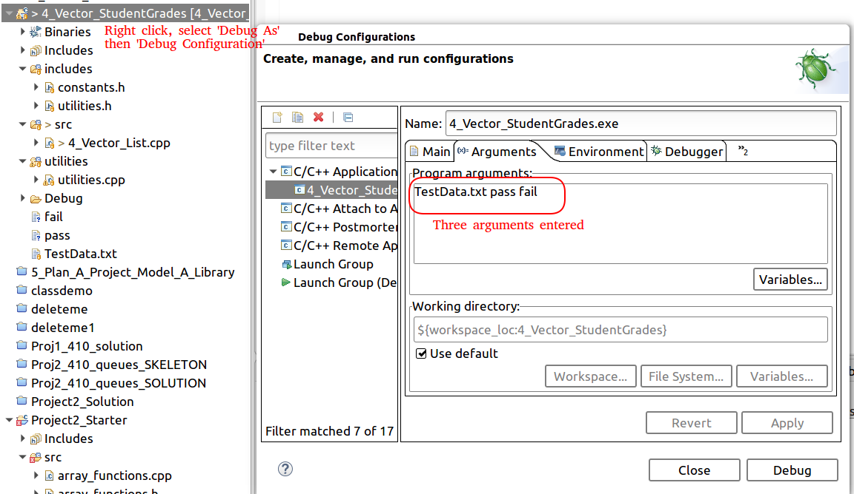

Pass at command line (note running from debug dir, and using ../TestData.txt

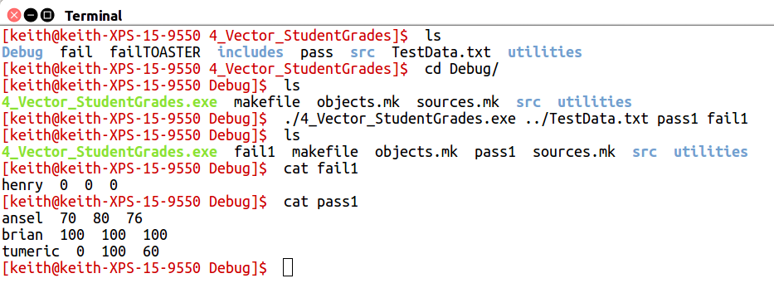

Writing a driver in another language (Python). This python file is part of the eclipse project BTW
